MAZON FIRE PROTECTION DISTRICT
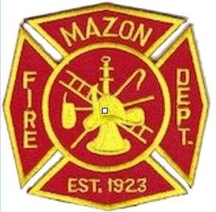
700 Park St. Mazon, IL 60444
Phone: 815-448-5460
Fax: 815-448-5670

NEWS RELEASE
For more information contact Chief Mark Brookman II at 815-448-5460 or E-Mail: mazonfd_3401@yahoo.com

One person injured in a two-vehicle crash
FOR IMMEDIATE RELEASE Friday 5/5/2023

On Thursday May 4th at 2041 hrs. the members of the Mazon Fire Department were called to the area of Rt 47 and Reed Rd in Mazon for the two-vehicle accident with entrapment and vehicle fire. The first arriving fire apparatus found a rolled-over SUV with heavy front end damage in the West ditch and a semi tractor-trailer hauling propane with heavy damage in the E ditch. Witnesses had stopped and pulled the driver from the burning SUV and extinguished the fire with an extinguisher. The SUV driver was treated and transported to Morris Hospital by Morris EMS, the driver of the semi was treated and released at the seen by MVK Ambulance. The semi tractor-trailer was not leaking any propane, however, was leaking a large amount of engine oil and diesel fuel. A Hazardous Material response was requested by the Incident Commander for the clean-up of the oil and diesel fuel. The Mazon Fire Department was assisted by Seneca Fire Protection District, Gardner Fire Protection District, Verona-Kinsman Fire Protection District, Morris Fire Protection District, Grundy County Emergency Management Agency, Grundy County Sheriff Department, and Gundy County Dispatch Center in the clean-up efforts. Rt 47 was closed for several hours due to the clean-up and was reopened around 2330hrs.

